IBS Data model

System Company Control FIle

IBS Join Logical for Web Tracking

Web Tracking

Package Information Header

Configured Item file IBS Business Partner File

IBS User Profile file IBS Contact File

Package Tracking Header Package Tracking Proof of Delivery

Orders

Tables

MFG Order-header Physical file

MFG Order-operation Physical file

MFG Order-oper.hist. Physical file

MFG Order-cap restr Physical file

Customer Sales order link

Invoice Search Header

Business Partner file

A/R Customer File

Customer - sales order info

Purchase order item lines

Sales order addresses

Sales order header

Sales order item line

Shipment line file

General text file

Control Record

Header

Line

Address

Customer Addresses

Sales Pricing & discount methods

Products

Configuration Item

Configuration Item Attributes

Configuration Values

Config Item Std item attr

Work file - attributes and formula values

View Configuration Item Attribute

View Configuration Parameter Attributes

Configurator Products

Item file

Inventory Management Information

Warehouse Balance

Time Transation Details

Order Flow Log

Cfg. User def table detail

Cfg. User def table hdr

Indesign

Interface with IN_Design for Excel orders - Header

Interface with In_Design for Excel orders - Attr

Fedex

Tracking number header for the FedEx/UPS interface

Tracking number detail for the FedEx/UPS interface

Tracking number PoD for the FedEx/UPS interface

Financial

Invoice Search Header

A/R Transaction file

## System Company Control FIle

This will be my last entry as I am in big trouble. It is because of this table and my inquisitive mind. This table stores the companies like TT/VP/etc that can be used in the system but there needs to be supporting table entries that go with it. I did not do this and it caused an issue for which I can not go on living. Stay away from this table or suffer the same fate.

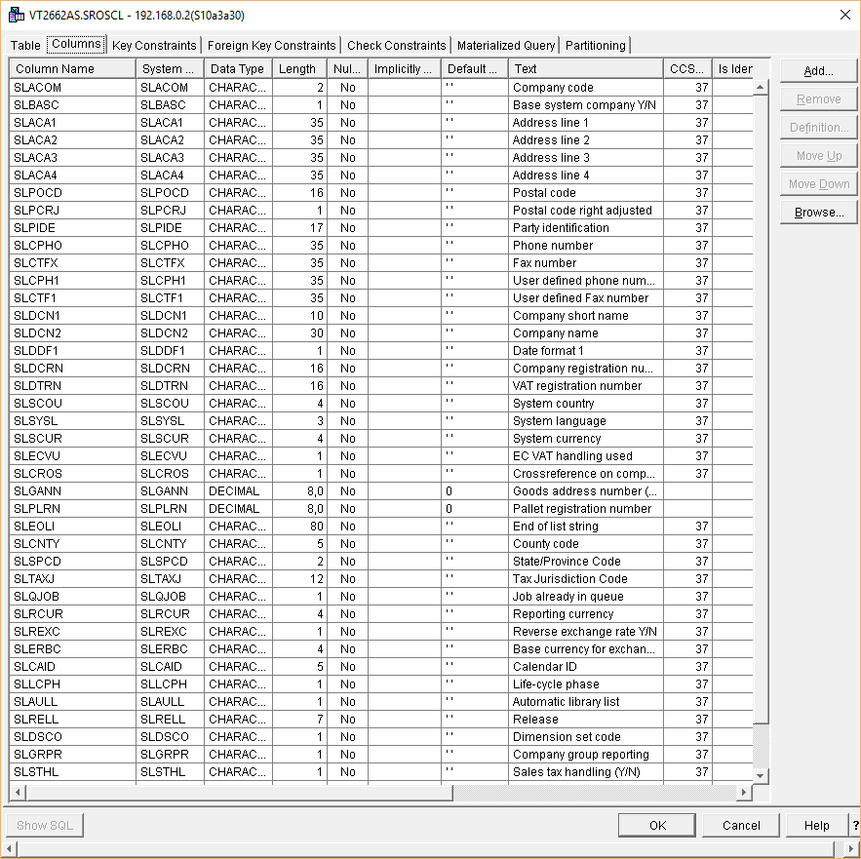

## 

## IBS Join Logical for Web Tracking

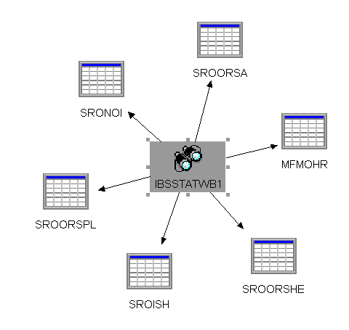

#### Web Tracking

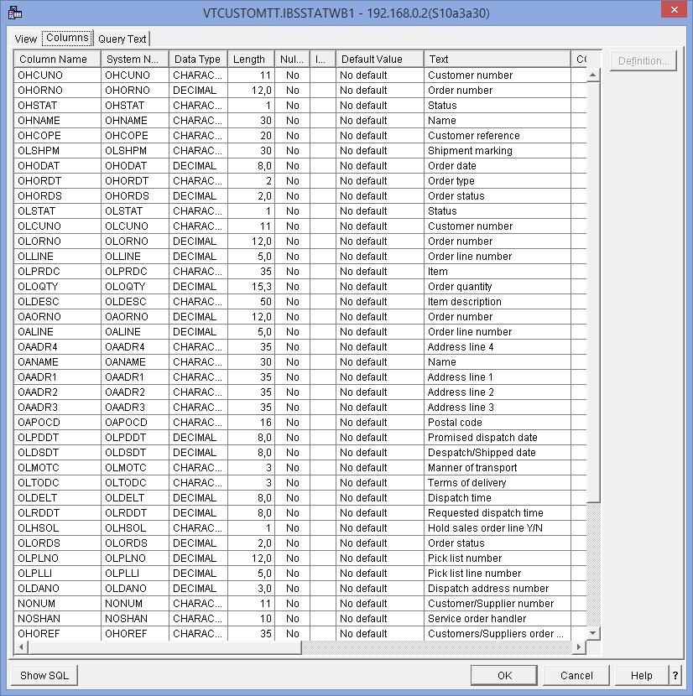

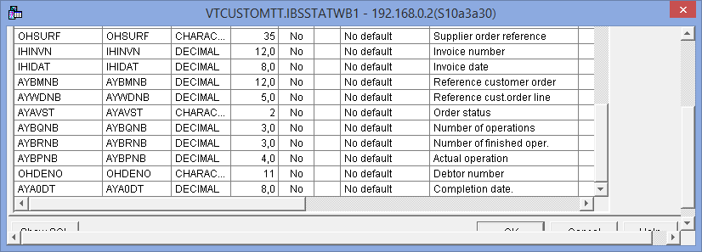

## 

## Package Information Header

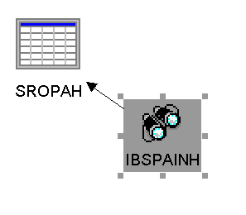

## Configured Item file IBS Business Partner File

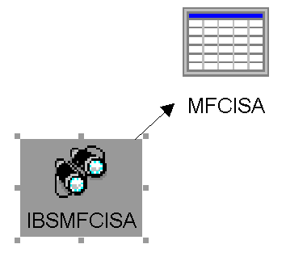 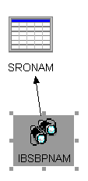

## IBS User Profile file IBS Contact File

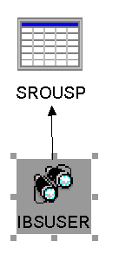 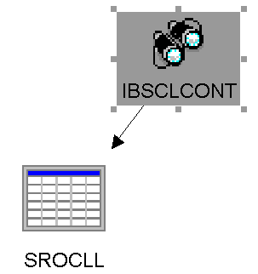

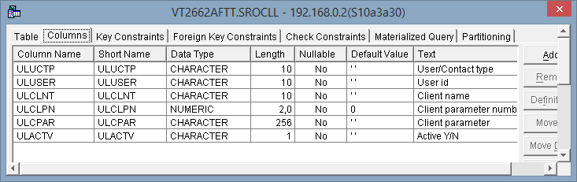

## Package Tracking Header Package Tracking Proof of Delivery

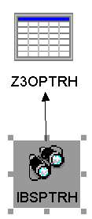 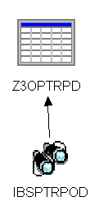

## Orders

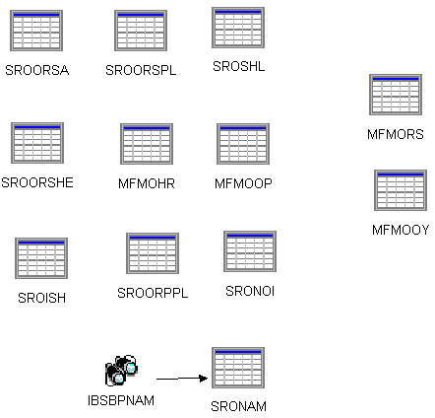

MFMOHR MFG Order-header Physical file

MFMOOP MFG Order-operation Physical file

MFMOOY MFG Order-oper.hist. Physical file

MFMORS MFG Order-cap restr Physical file

MFCULI Customer Sales order link

SROISH Invoice Search Header

SRONAM Business Partner file

SRONOI Customer - sales order info

SROORPPL Purchase order item lines

SROORSA Sales order addresses -- SR2SOA is the view

SROORSHE Sales order header -- SRBSOH is the view

SROORSPL Sales order item line

SROSHL Shipment line file

SROTGT General text file

SRODCO Control Record

SROORDERS1 Header

SROORDERS3 Line

SROORDERS2 Address

SRONAD Customer Addresses

SRBDID Sales Pricing & discount methods

### Tables

The following is more detailed information on the tables.

#### MFG Order-header Physical file

1 of 2

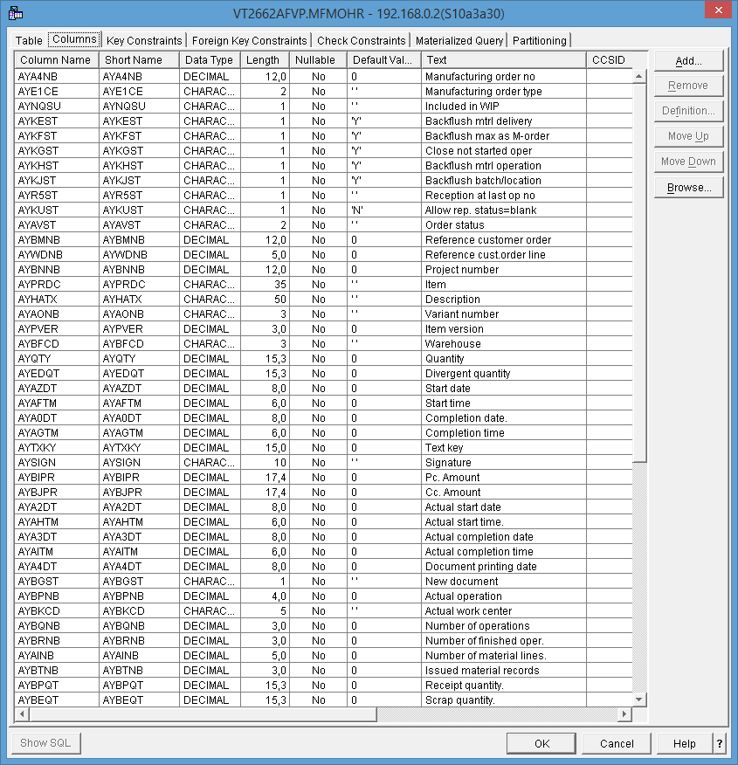

2 of 2

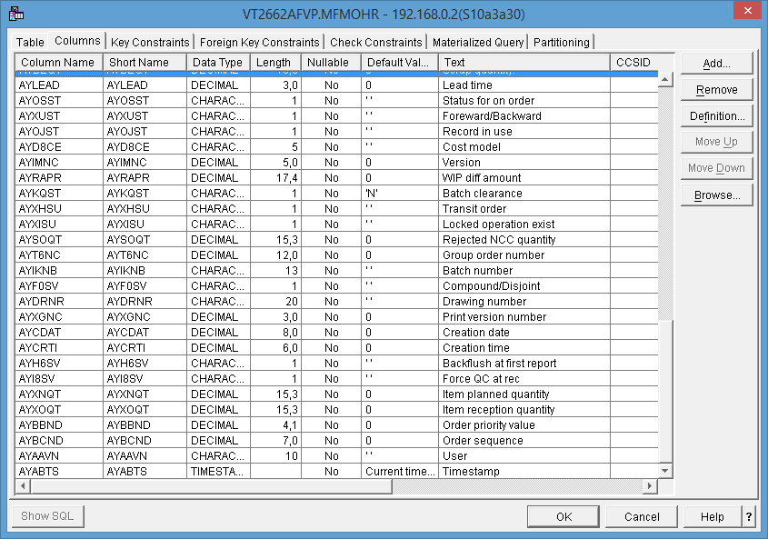

#### MFG Order-operation Physical file

1 of 2

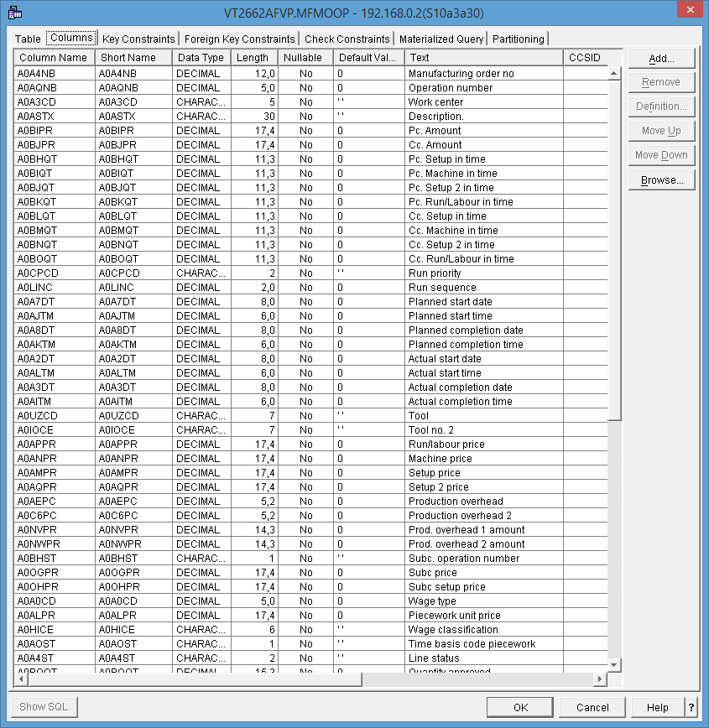

2 of 2

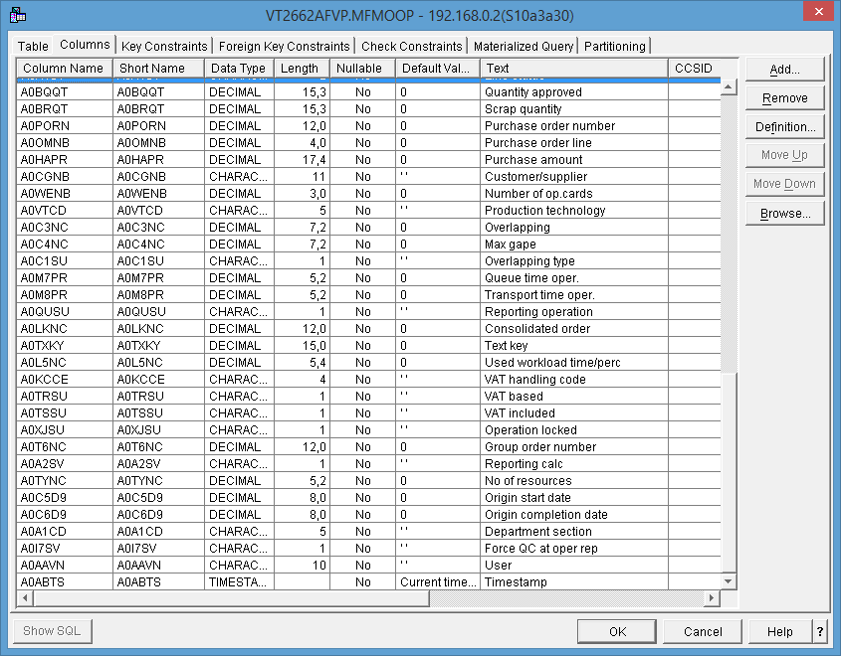

#### MFG Order-oper.hist. Physical file

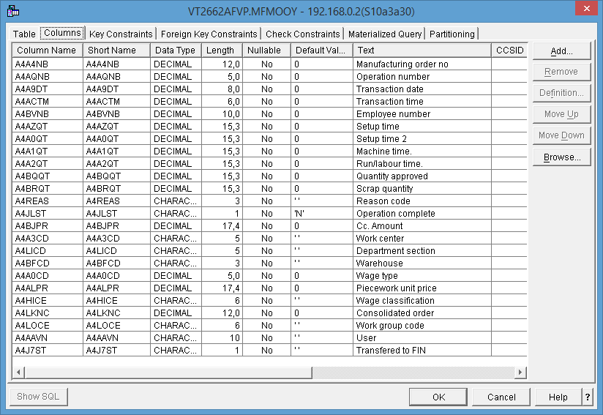

#### MFG Order-cap restr Physical file

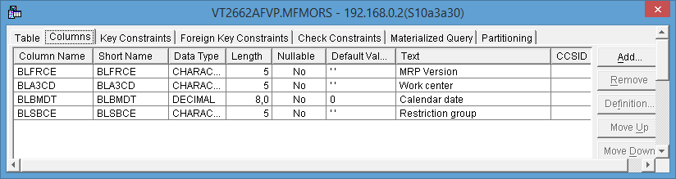

#### Customer Sales order link

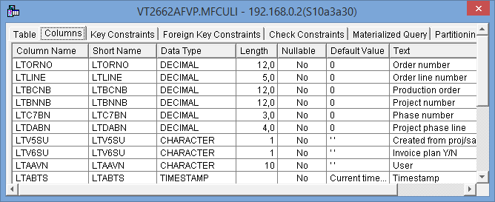

#### Invoice Search Header

1 of 3

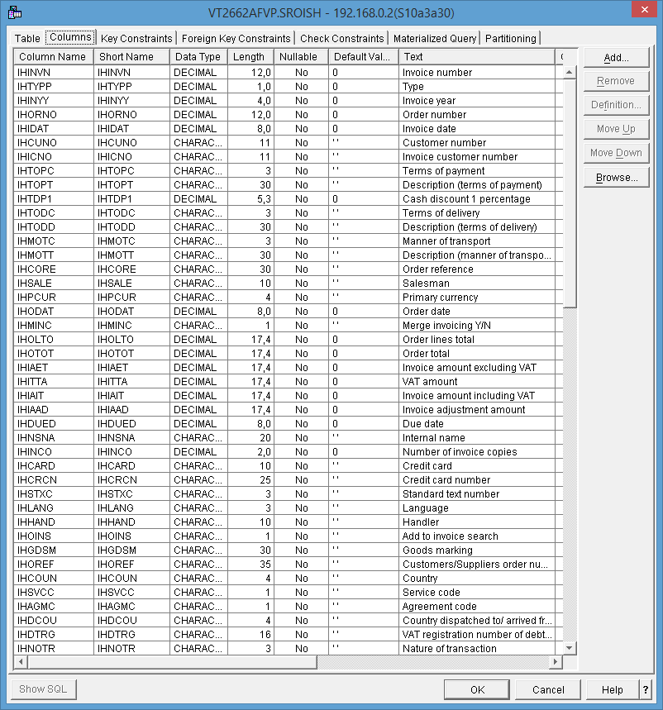

2 of 3

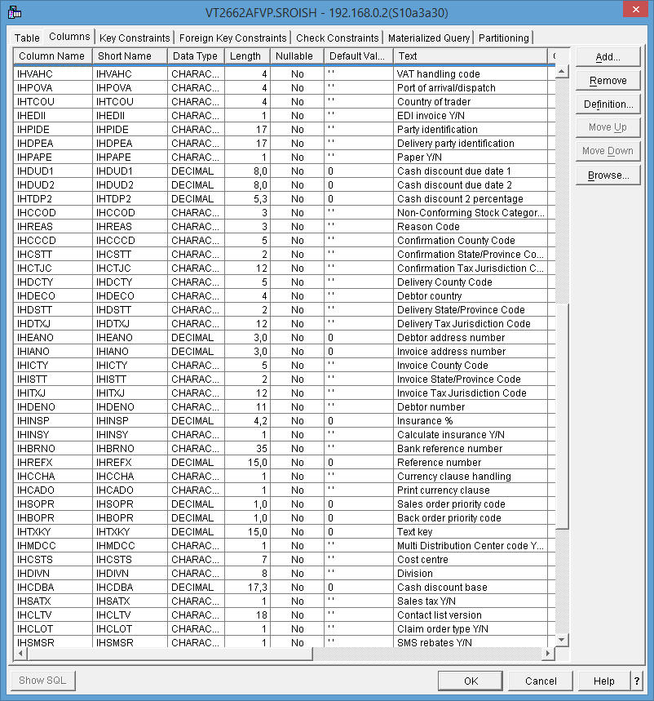

3 of 3

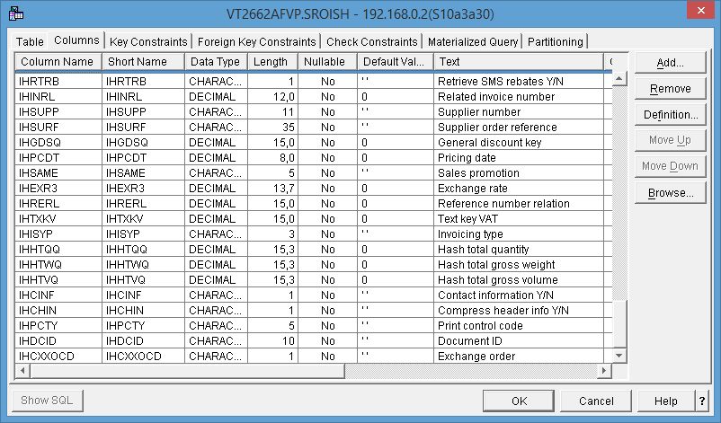

#### Business Partner file

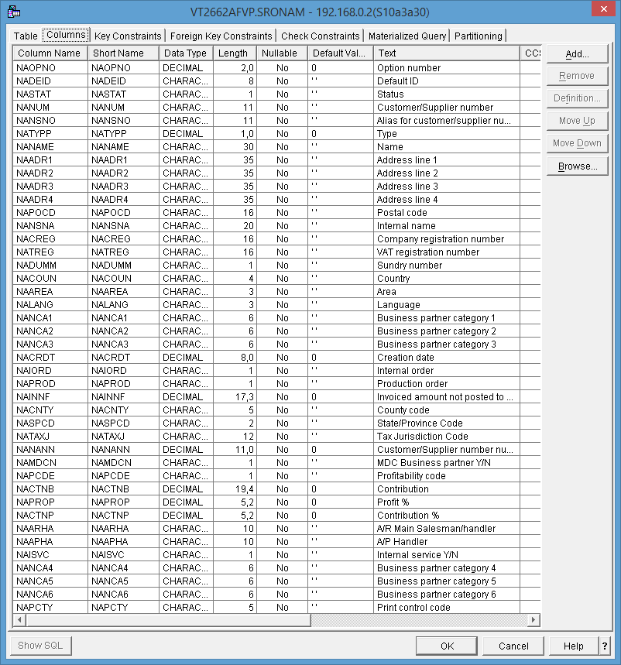

#### A/R Customer File

1 of 2

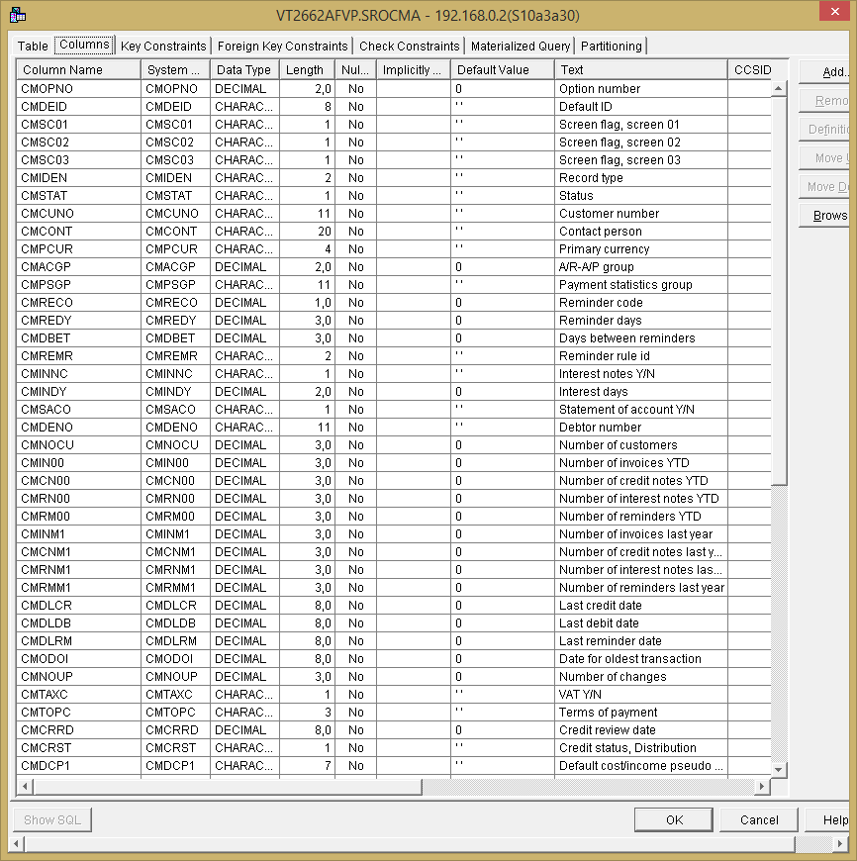

2 of 2

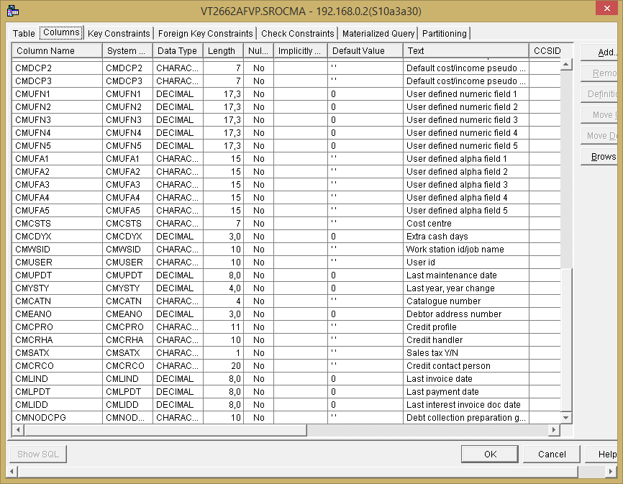

#### Customer - sales order info

1 of 3

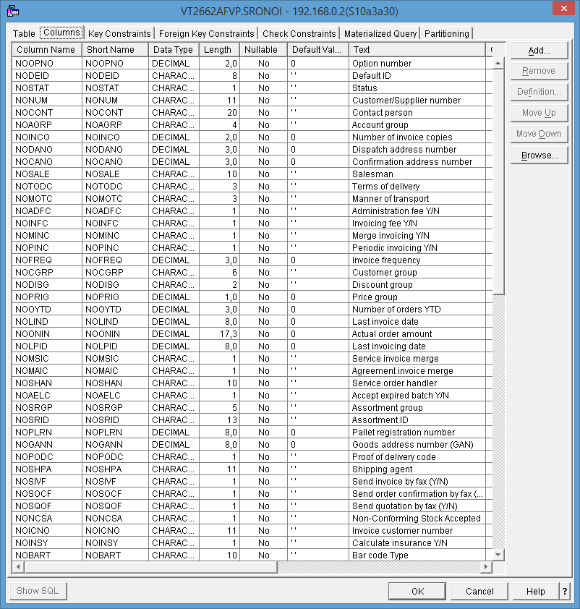

2 of 3

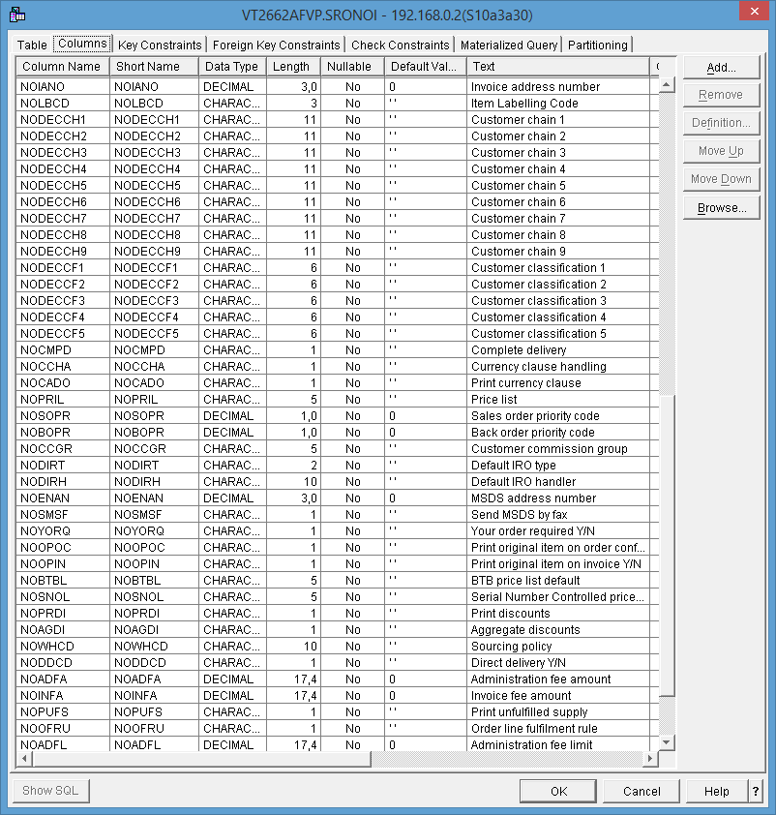

3 of 3

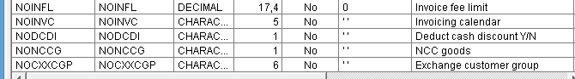

#### Purchase order item lines

1 of 5

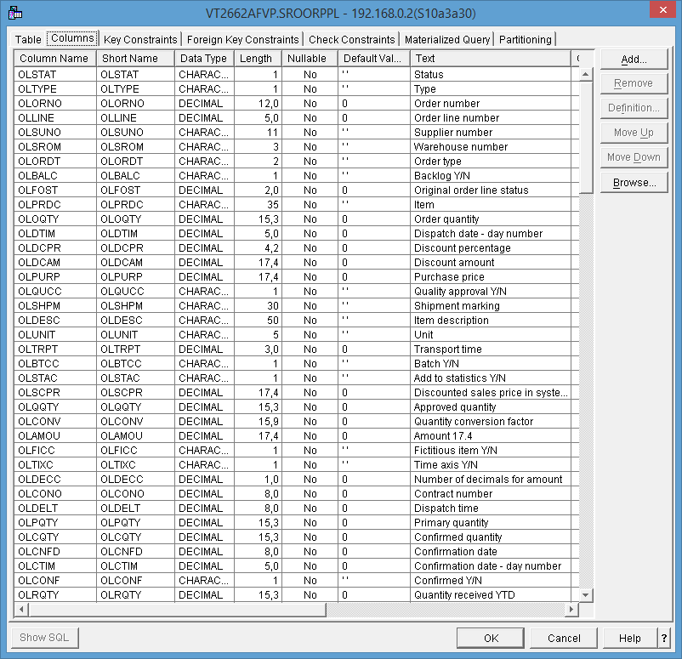

2 of 5

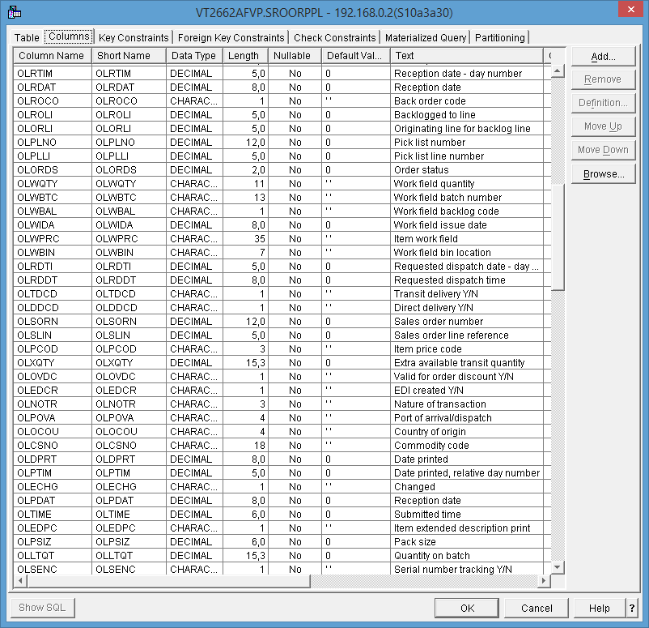

3 of 5

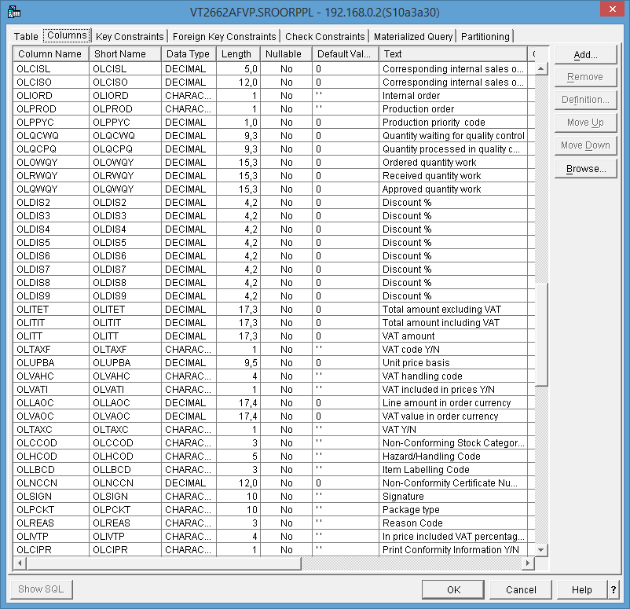

4 of 5

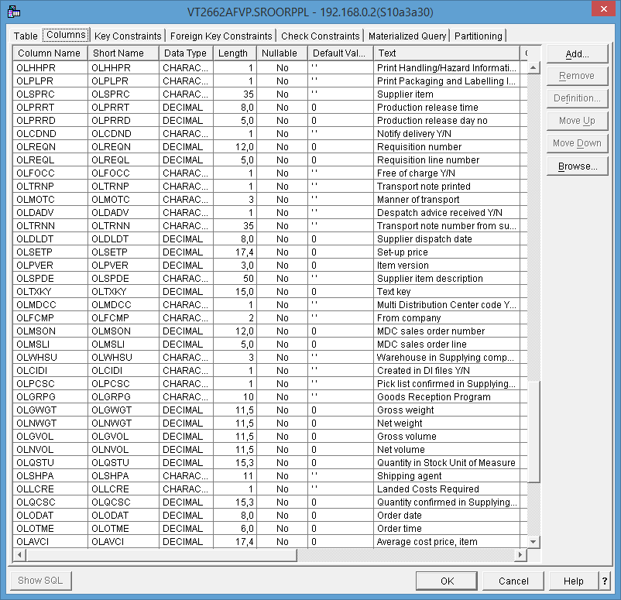

5 of 5

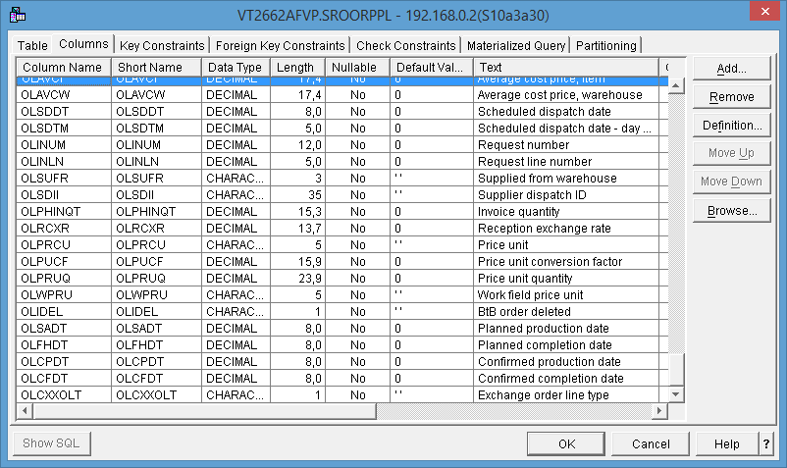

#### Sales order addresses

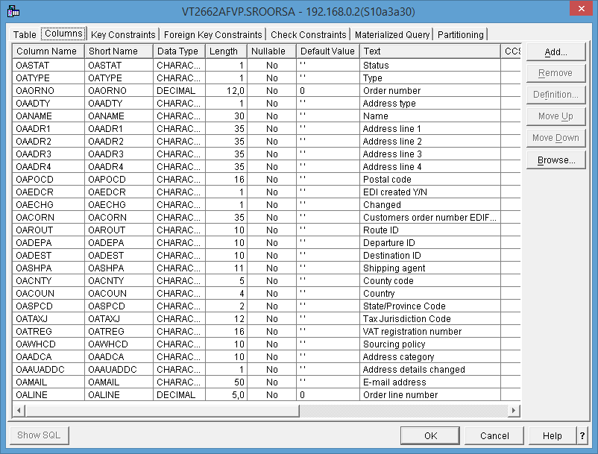

#### Sales order header

1 of 6

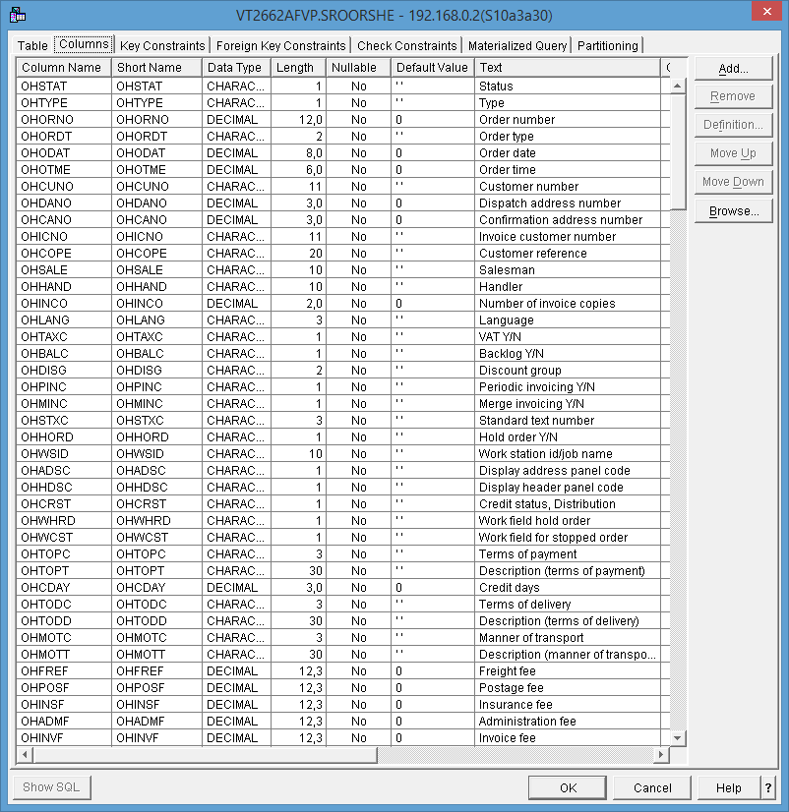

2 of 6

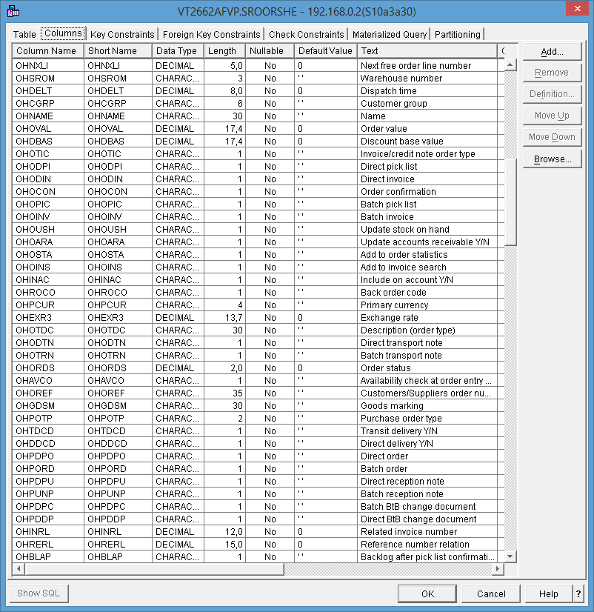

3 of 6

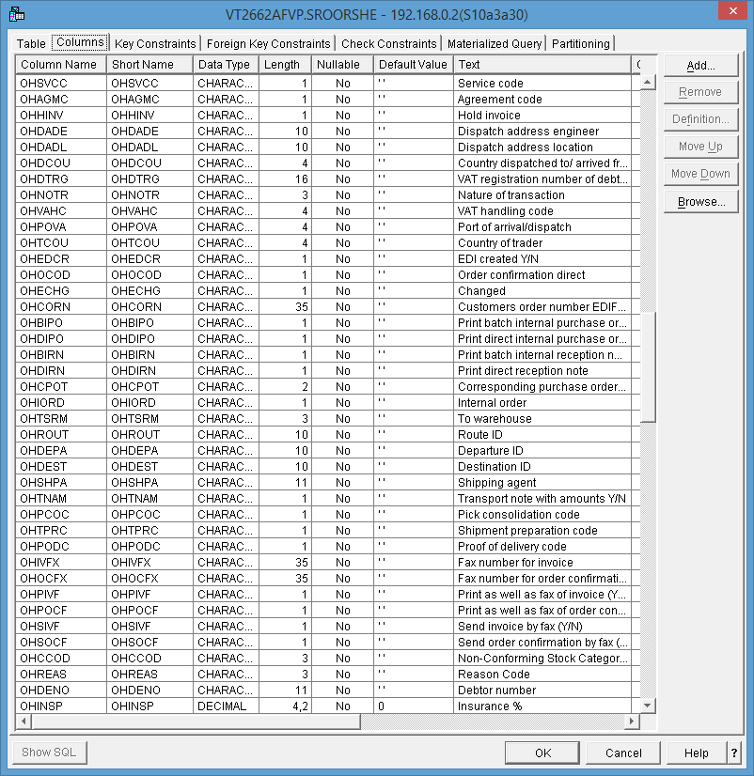

4 of 6

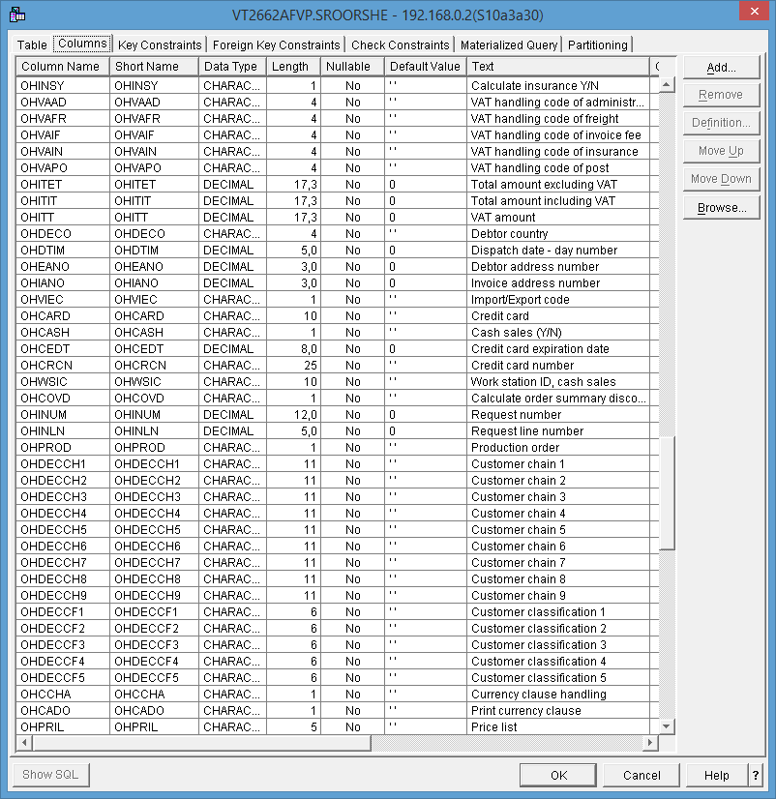

5 of 6

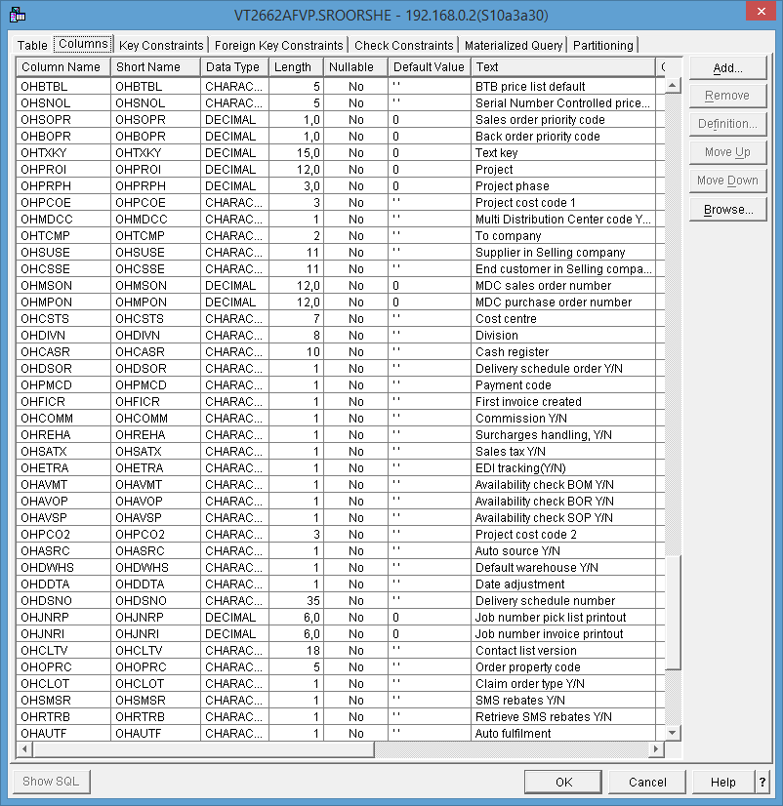

6 of 6

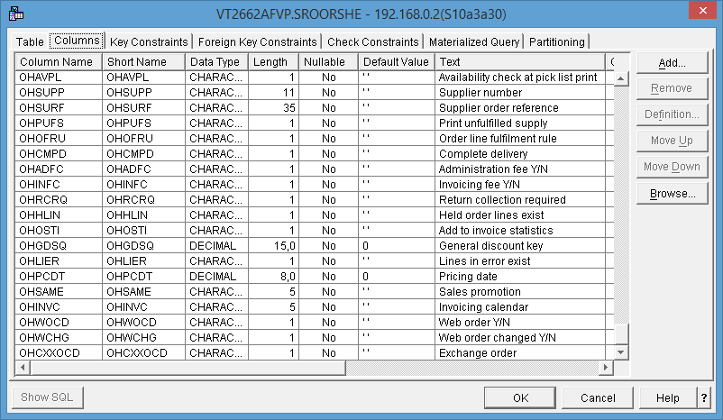

#### Sales order item line

1 of 5

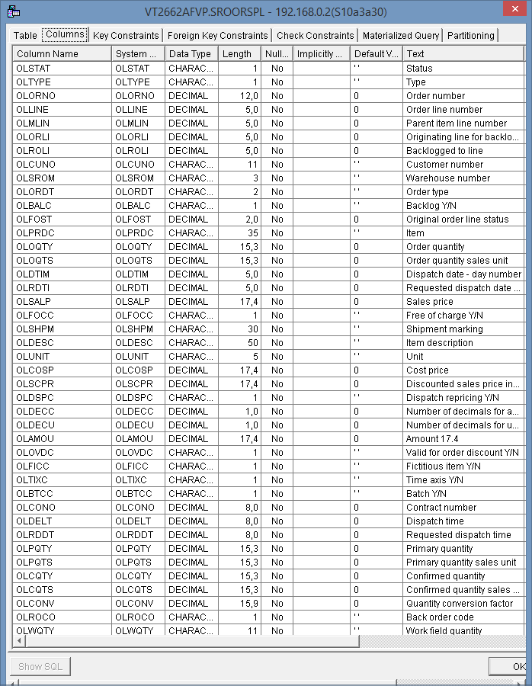

2 of 5

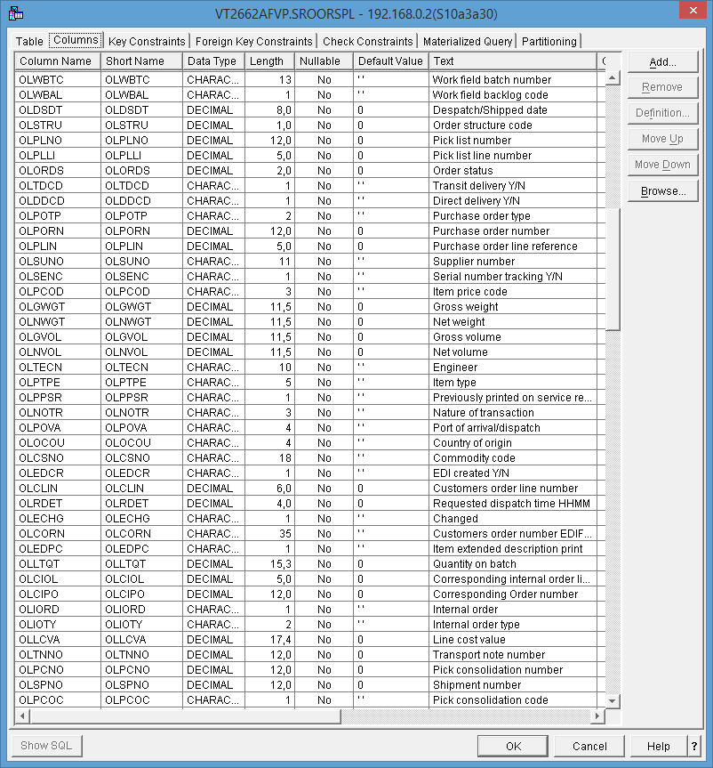

3 of 5

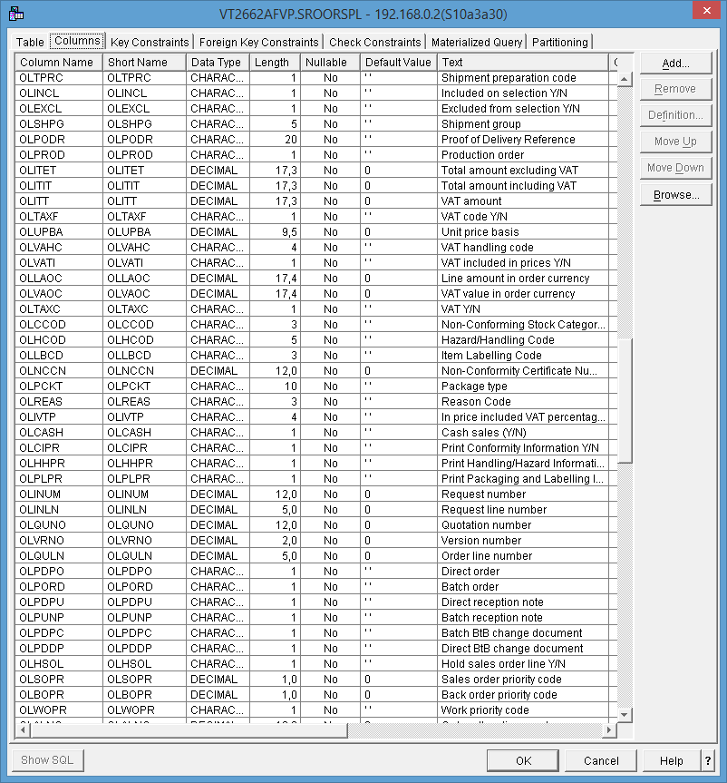

4 of 5

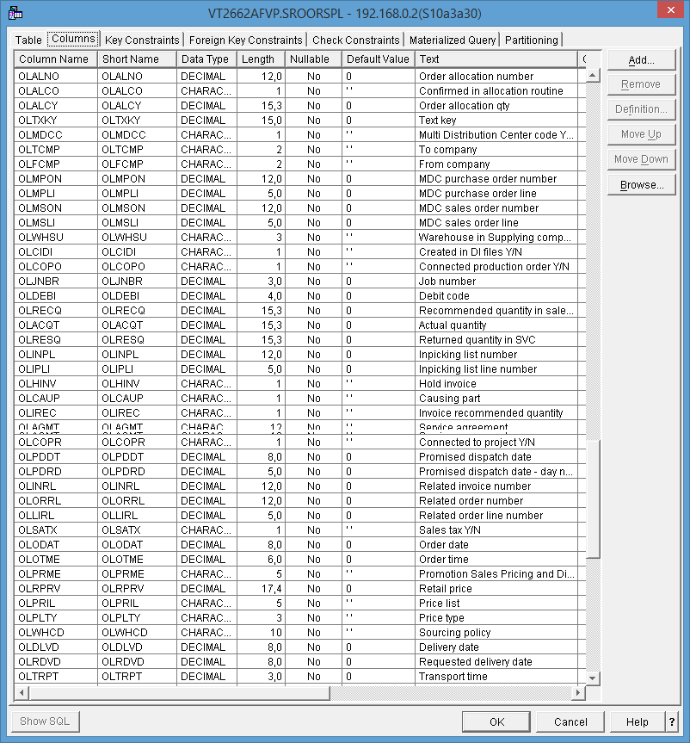

5 of 5

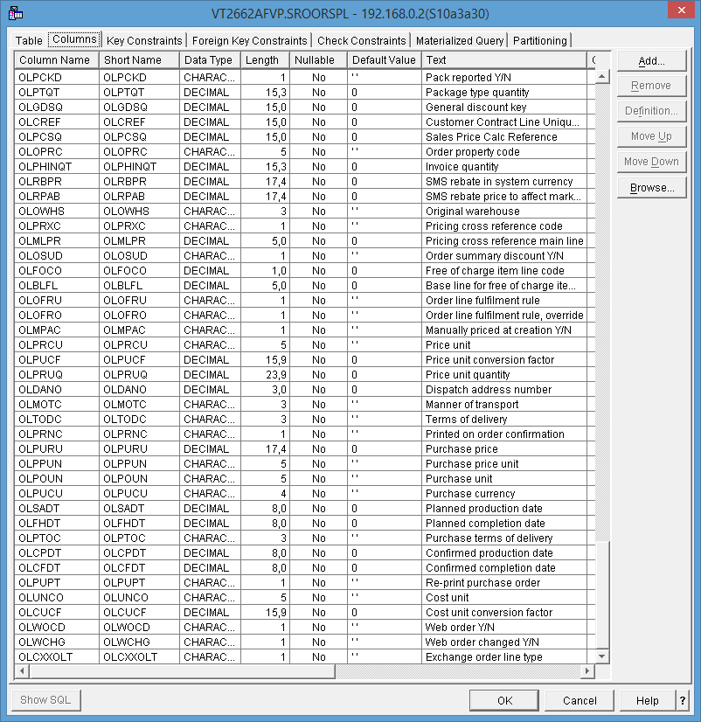

#### Shipment line file

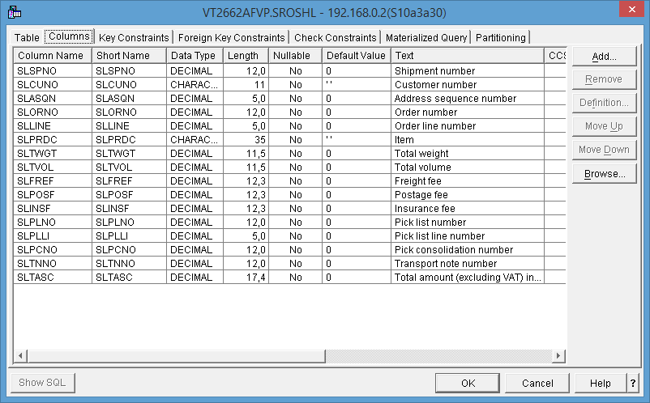

#### General text file

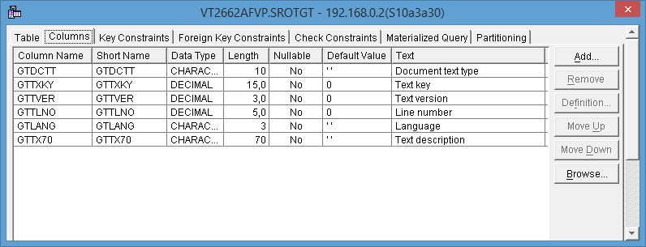

#### Control Record

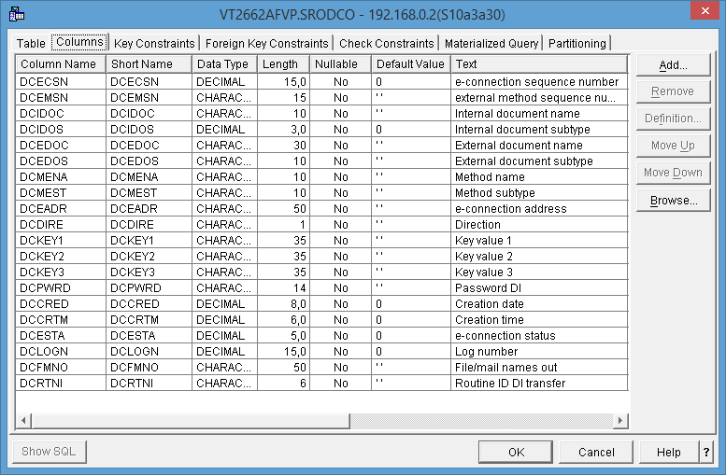

#### Header

1 of 5

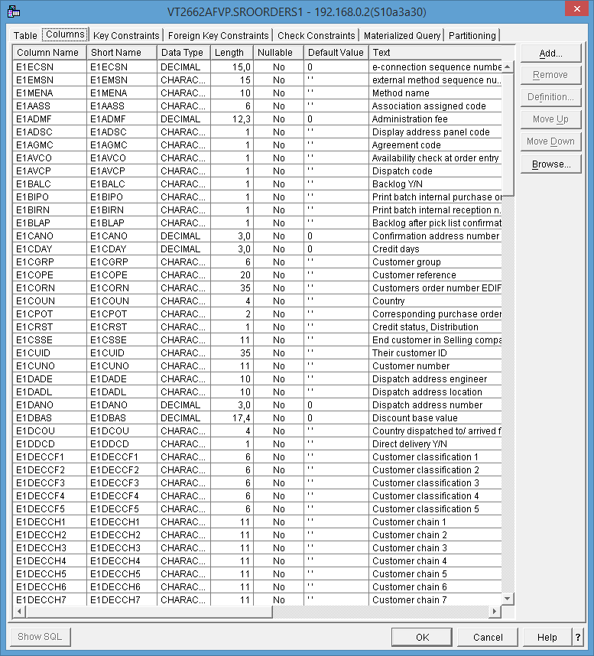

2 of 5

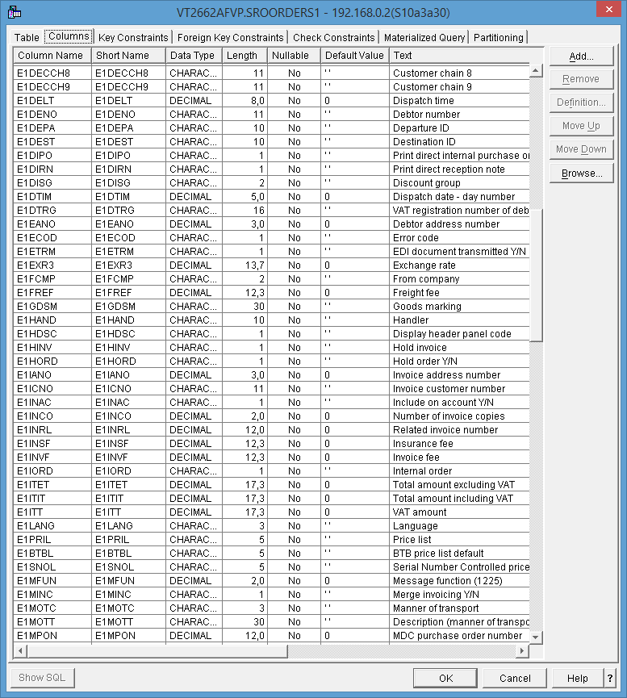

3 of 5

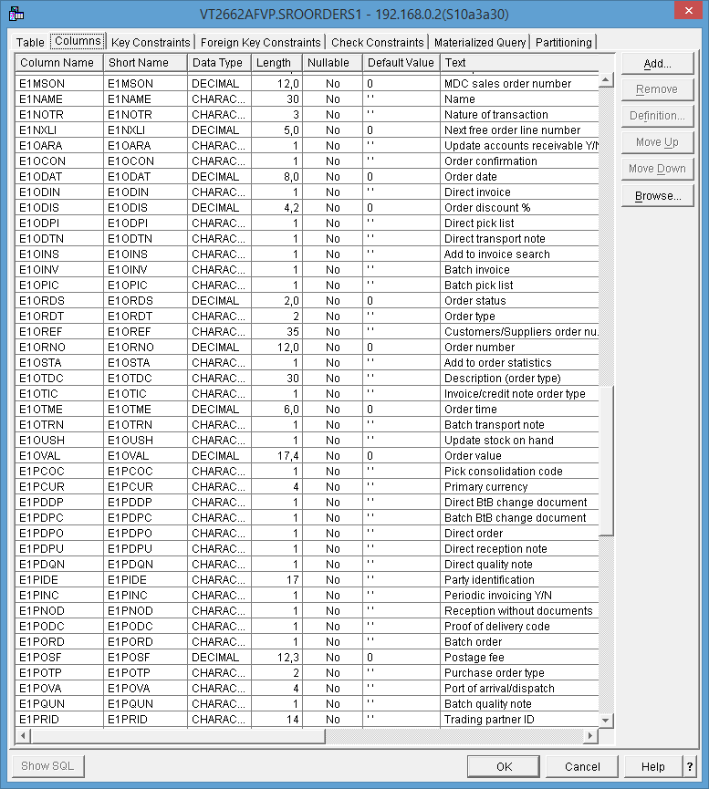

4 of 5

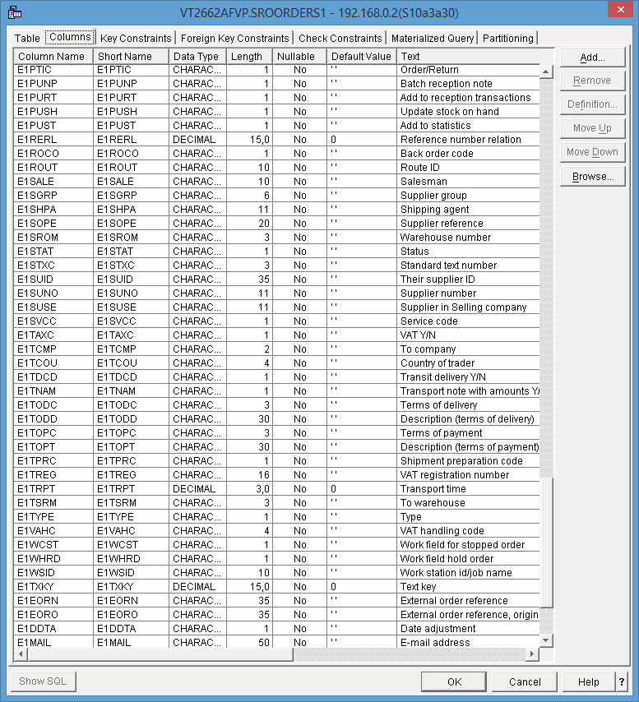

5 of 5

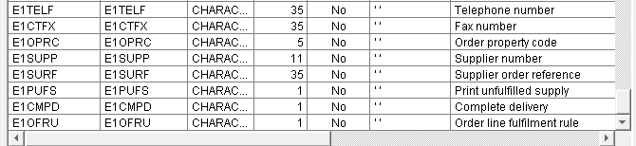

#### Line

1 of 4

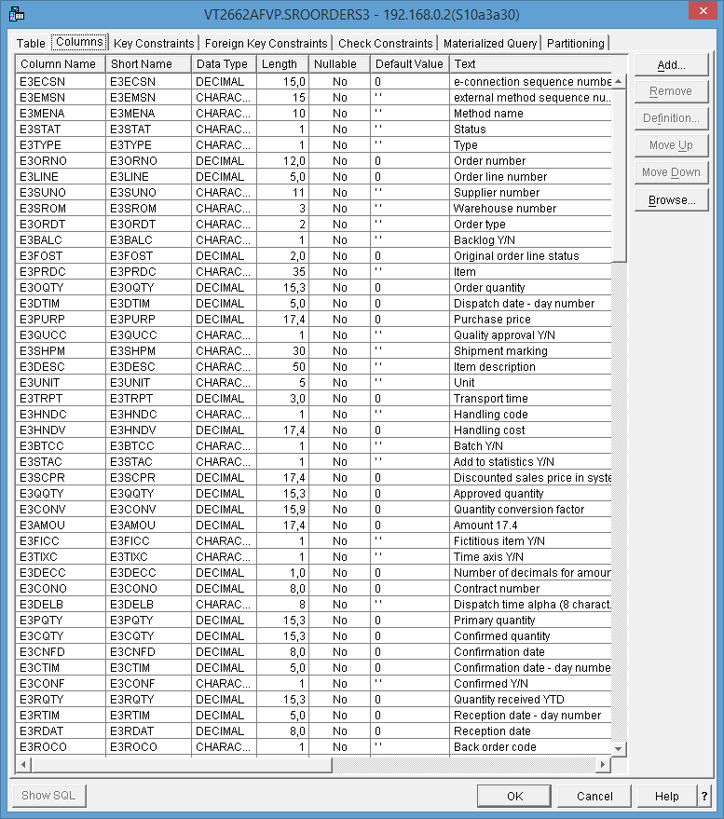

2 of 4

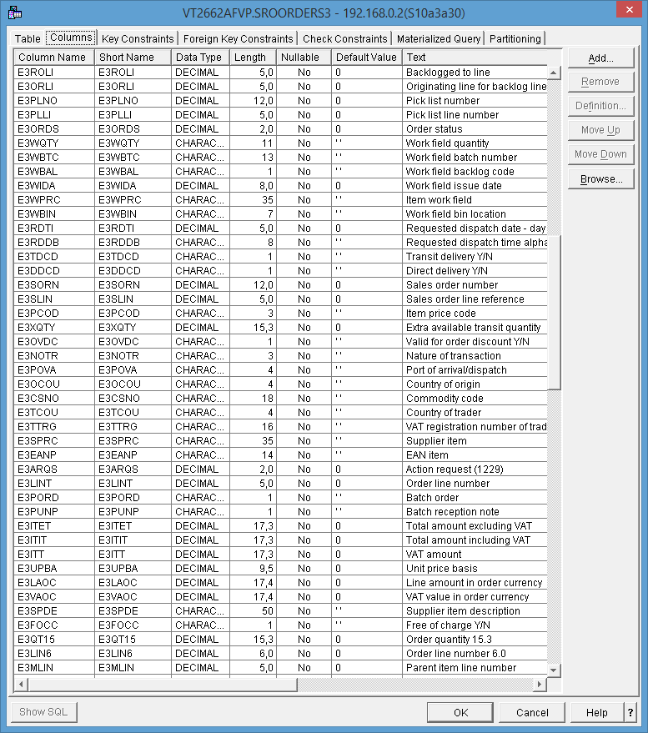

3 of 4

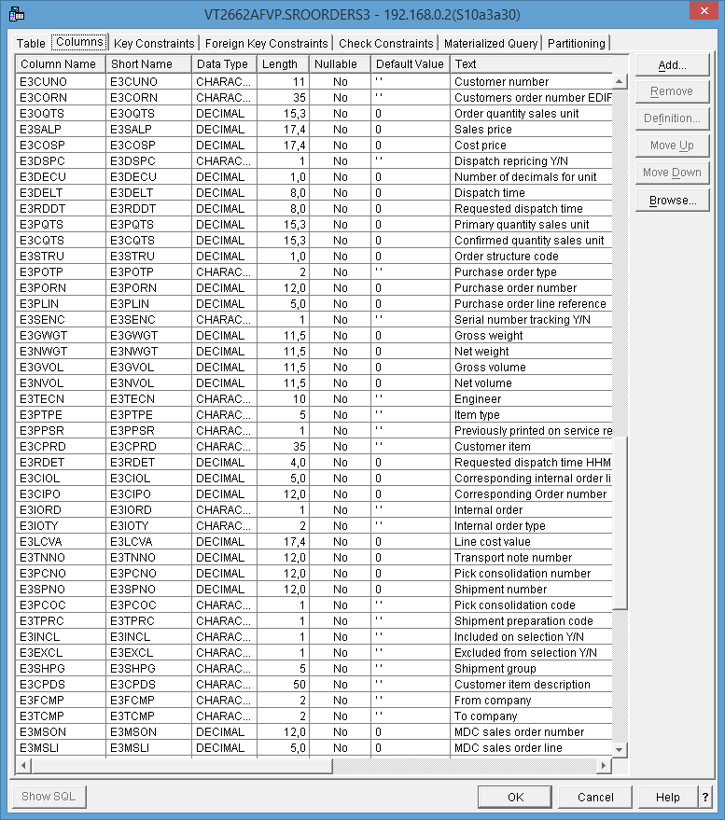

4 of 4

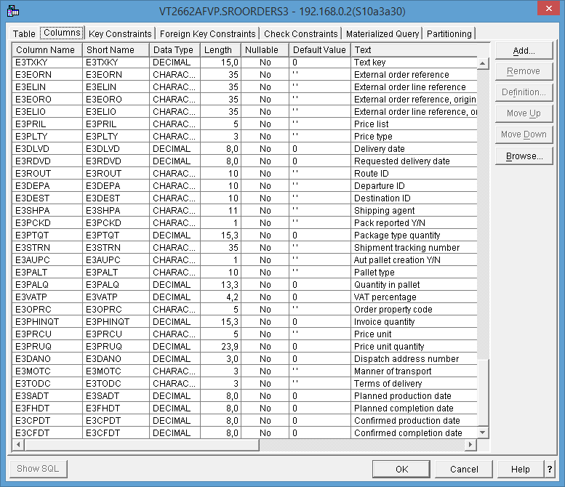

#### Address

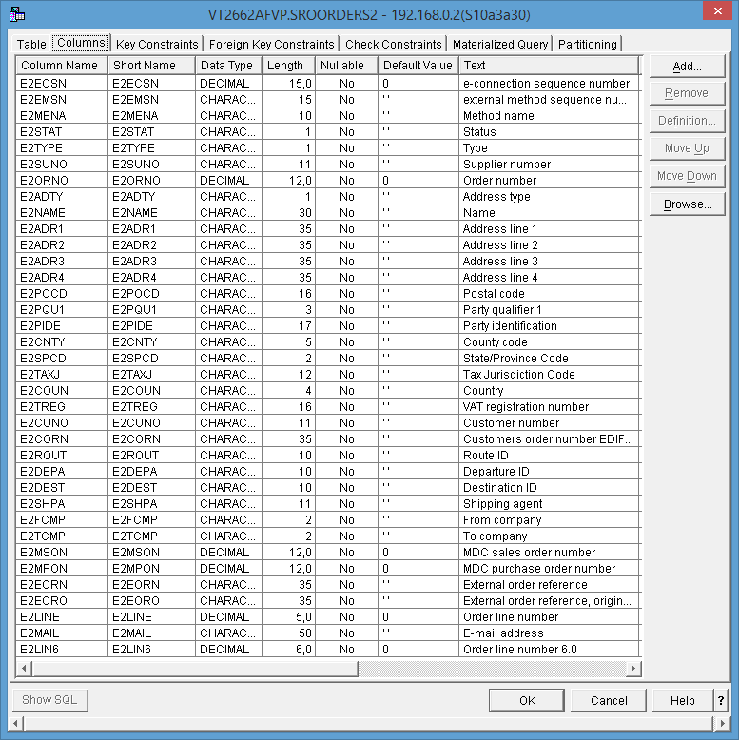

### 

### 

#### Customer Addresses

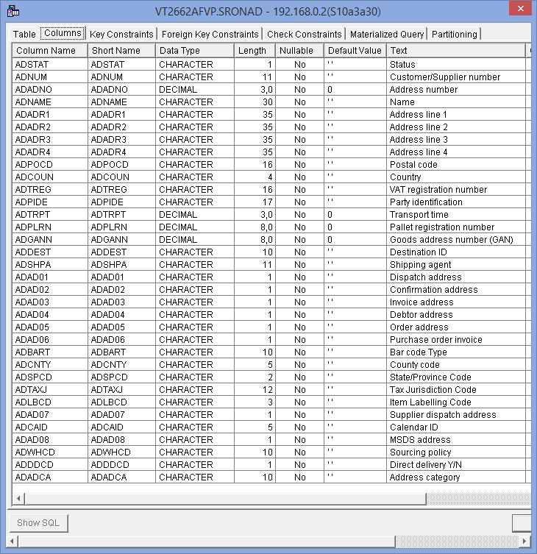

#### Sales Pricing & discount methods

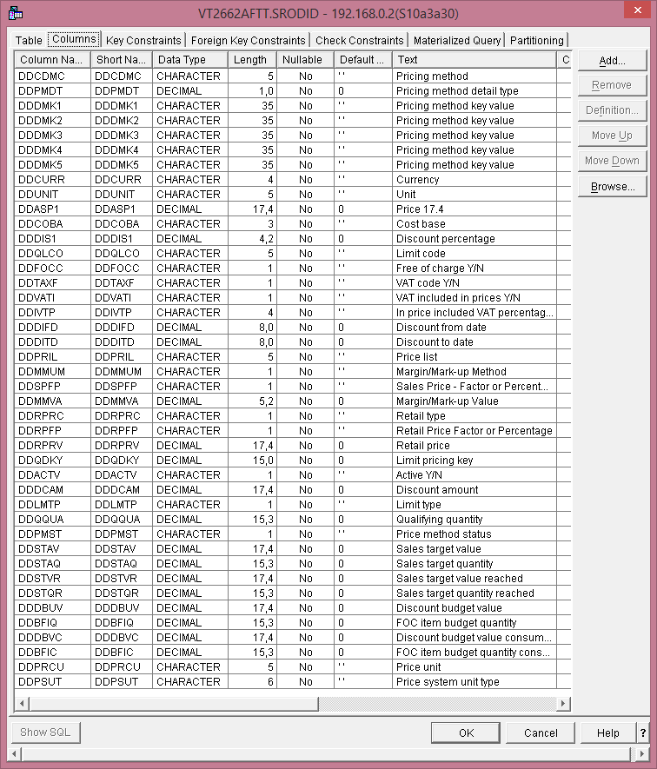

#### 

## Products

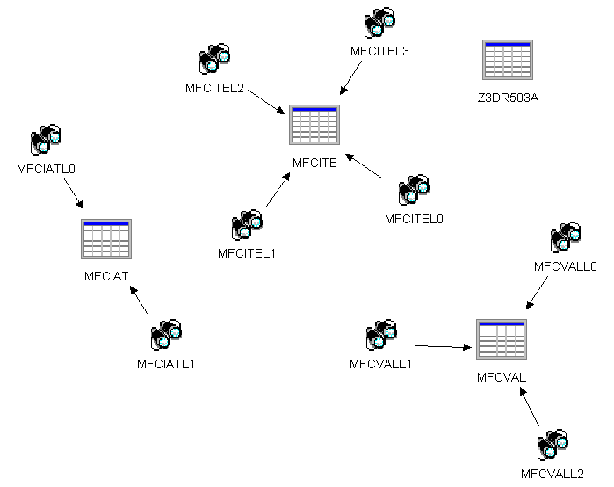

MFCITE Configuration Item

MFCIAT Configuration Item Attributes

MFCVAL Configuration Values

MFCISA Config Item Std item attr

Z3DR503A Work file - attributes and formula values

#### Configuration Item

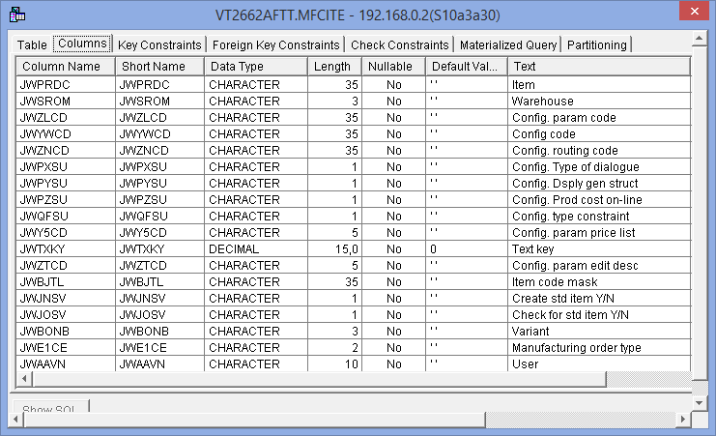

#### Configuration Item Attributes

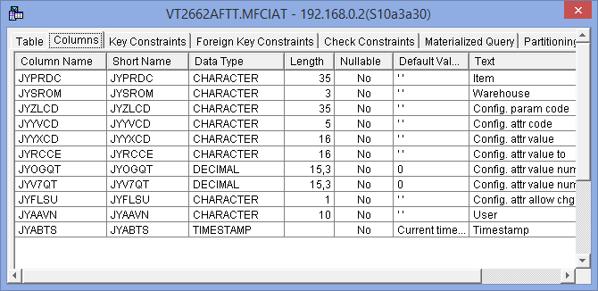

#### Configuration Values

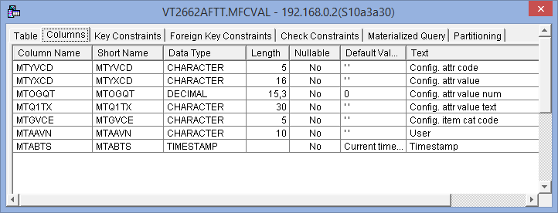

#### Config Item Std item attr

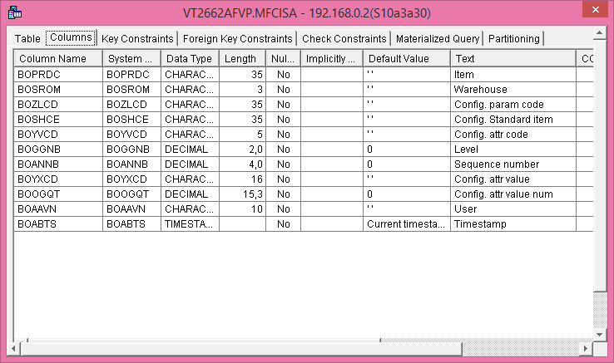

#### Work file - attributes and formula values

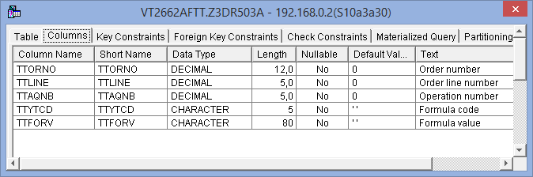

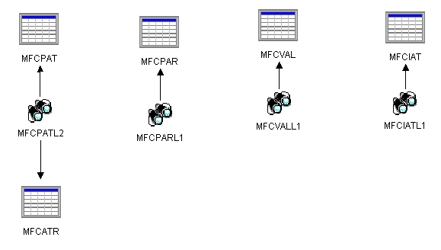

MFCIATL1 View Configuration Item Attribute

MFCPATL2 View Configuration Parameter Attributes

SROCTLPL - Sales Price List Table

SROPRS - Item sales price

SROSPRS Item sales price information history

#### View Configuration Item Attribute

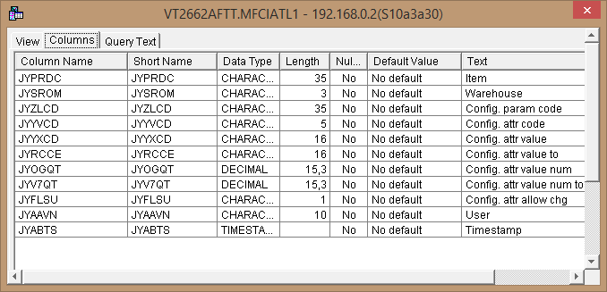

#### View Configuration Parameter Attributes

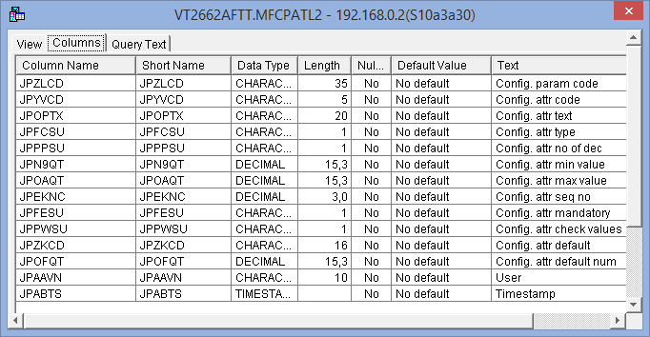

## Configurator Products

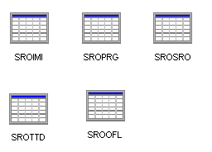

SROPRG Item file

SROIMI Inventory Management Information

SROSRO Warehouse Balance

SROTTD Time Transation Details

SROOFL Order Flow Log

MFUDTD Cfg. User def table detail

MFUDTH Cfg. User def table hdr

#### 

#### 

#### Item file

1of 4

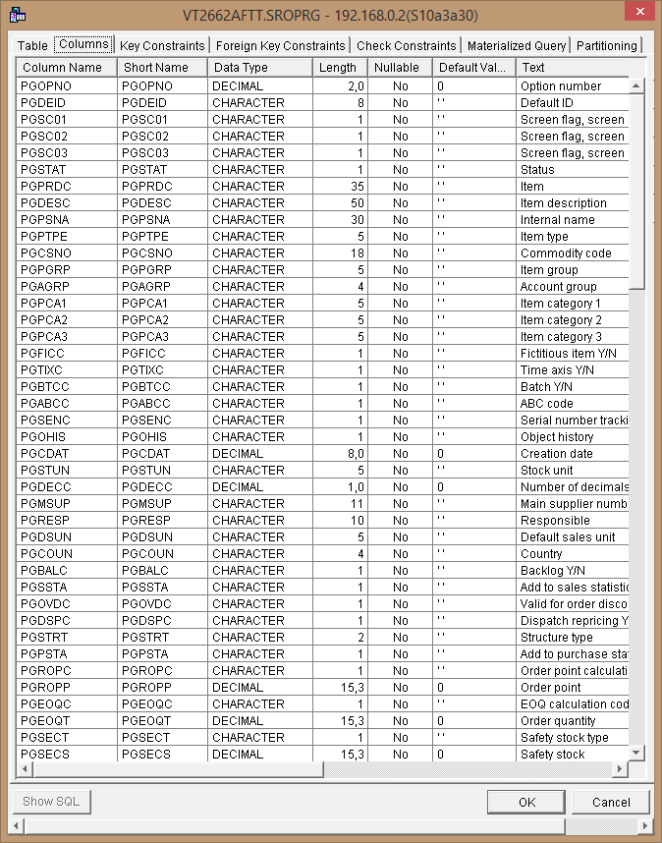

2 of 4

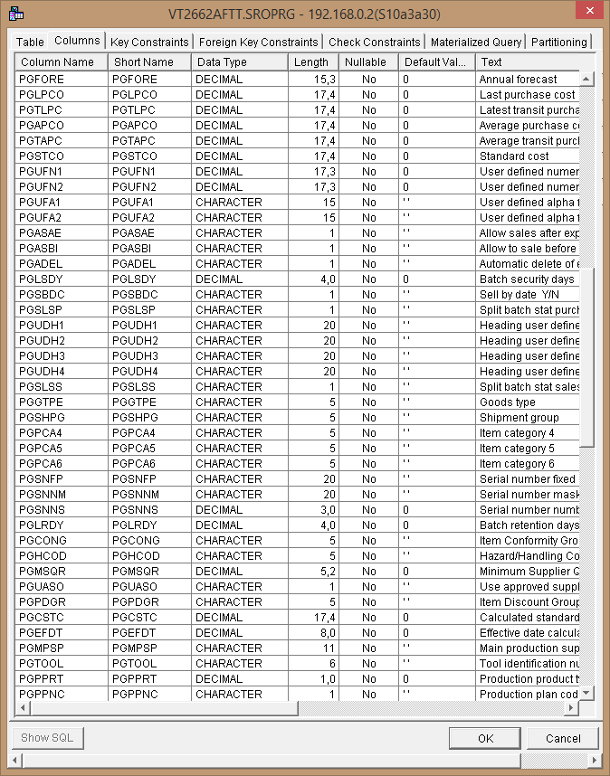

3 of 4

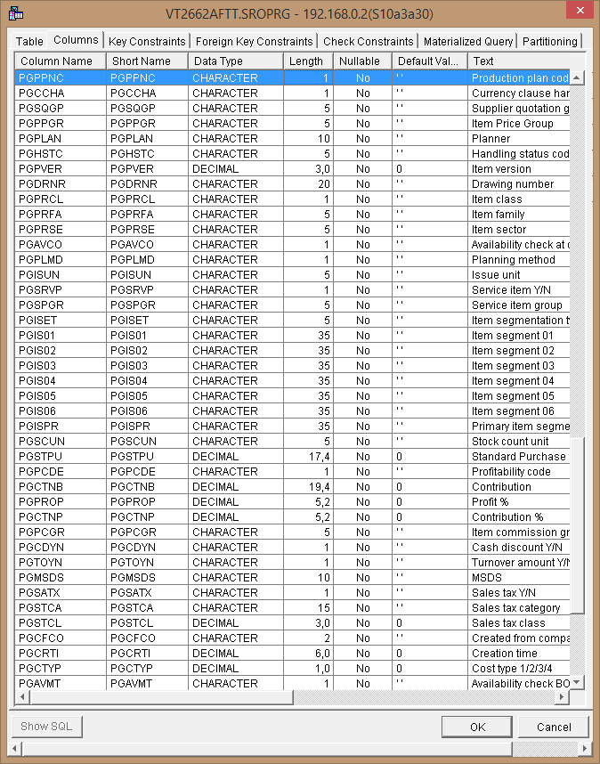

4 of 4

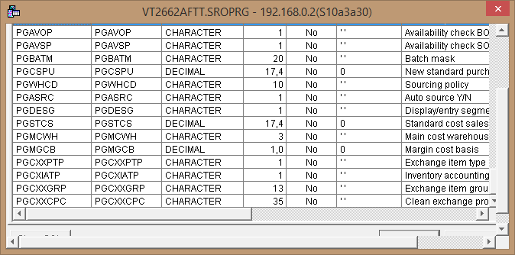

#### Inventory Management Information

1 of 2

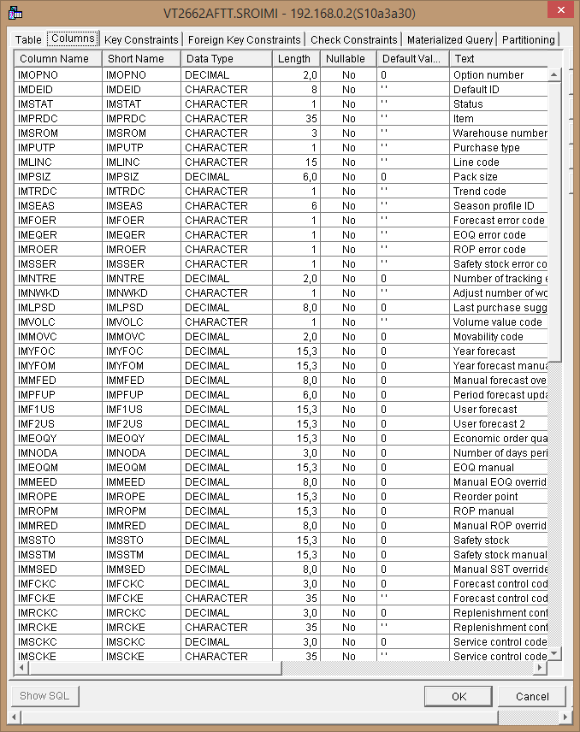

2 of 2

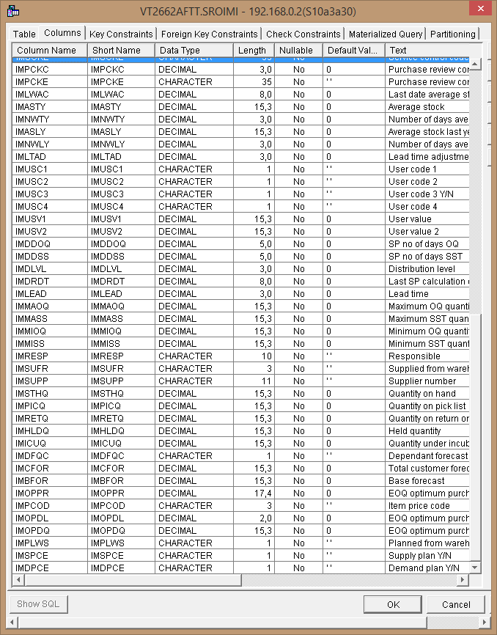

#### Warehouse Balance

1 of 3

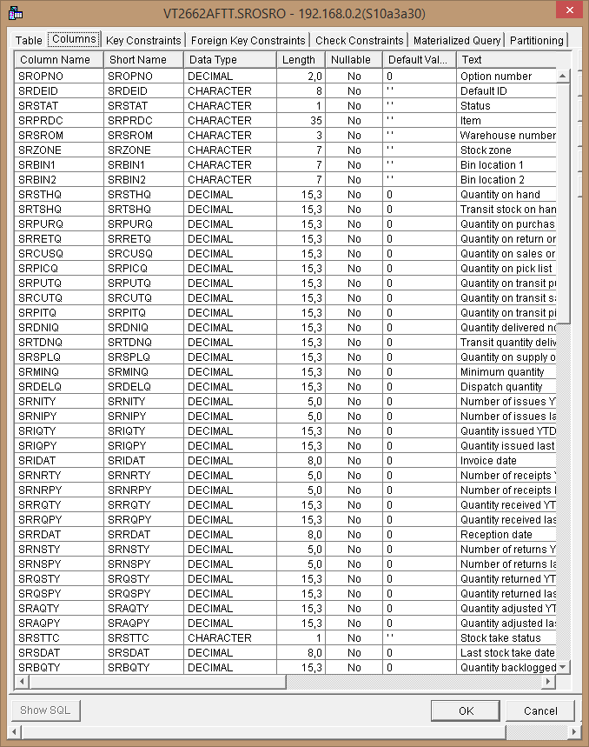

2 of 3

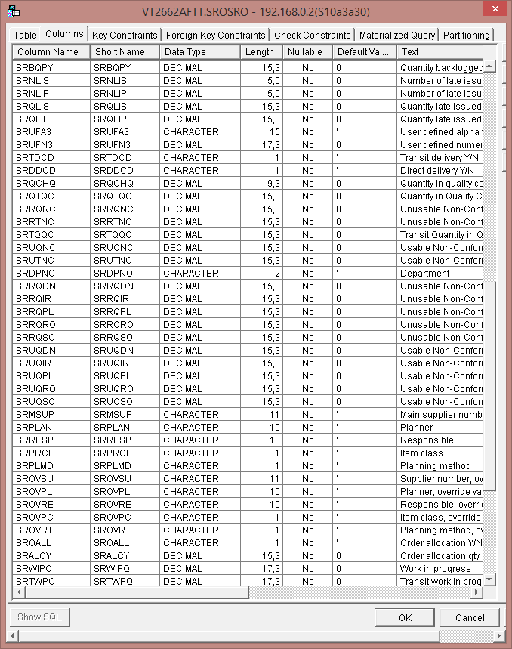

3 of 3

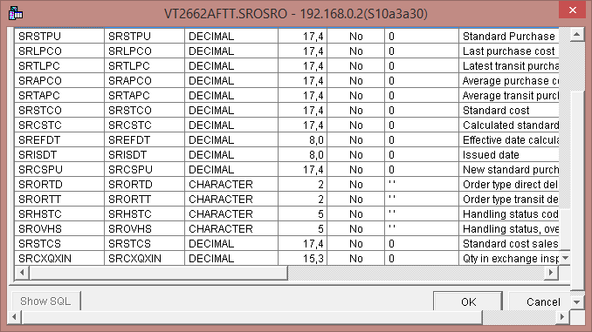

#### Time Transation Details

#### 

#### 

#### 

#### Order Flow Log

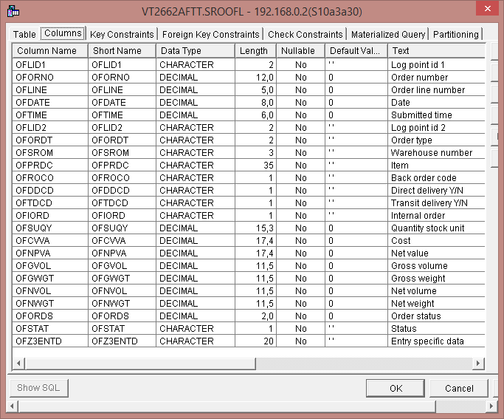

#### 

#### Cfg. User def table detail

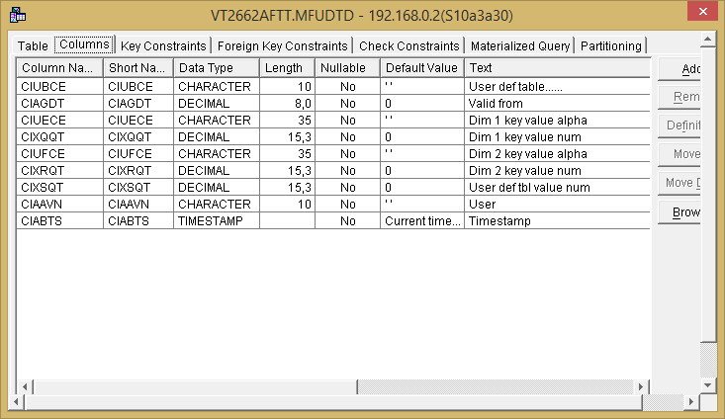

#### Cfg. User def table hdr

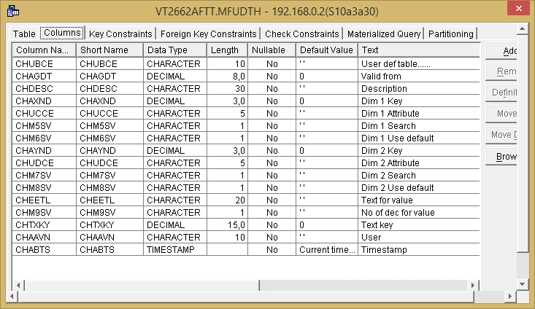

## Indesign

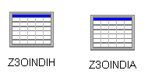

#### Interface with IN_Design for Excel orders - Header

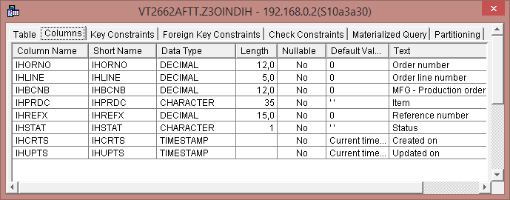

#### Interface with In_Design for Excel orders - Attr

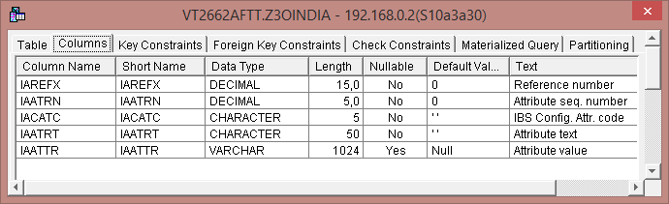

## Fedex

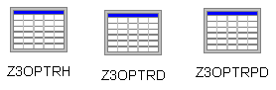

#### Tracking number header for the FedEx/UPS interface

## 

## 

## 

#### Tracking number detail for the FedEx/UPS interface

#### 

#### Tracking number PoD for the FedEx/UPS interface

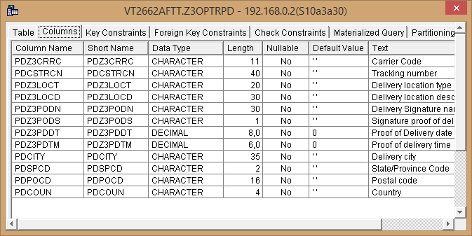

#### 

## Financial

### Invoice Search Header

1 of 3

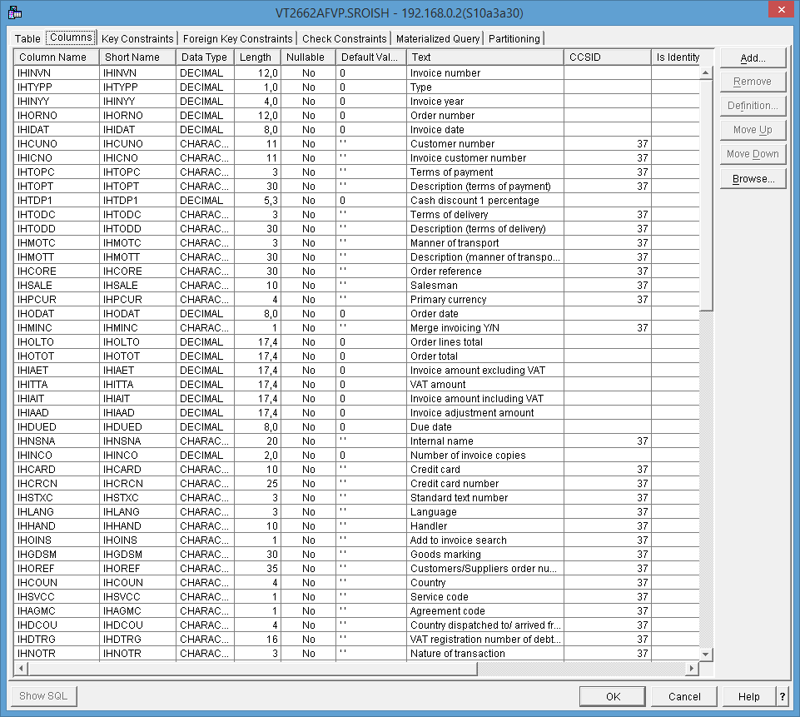

2 of 3

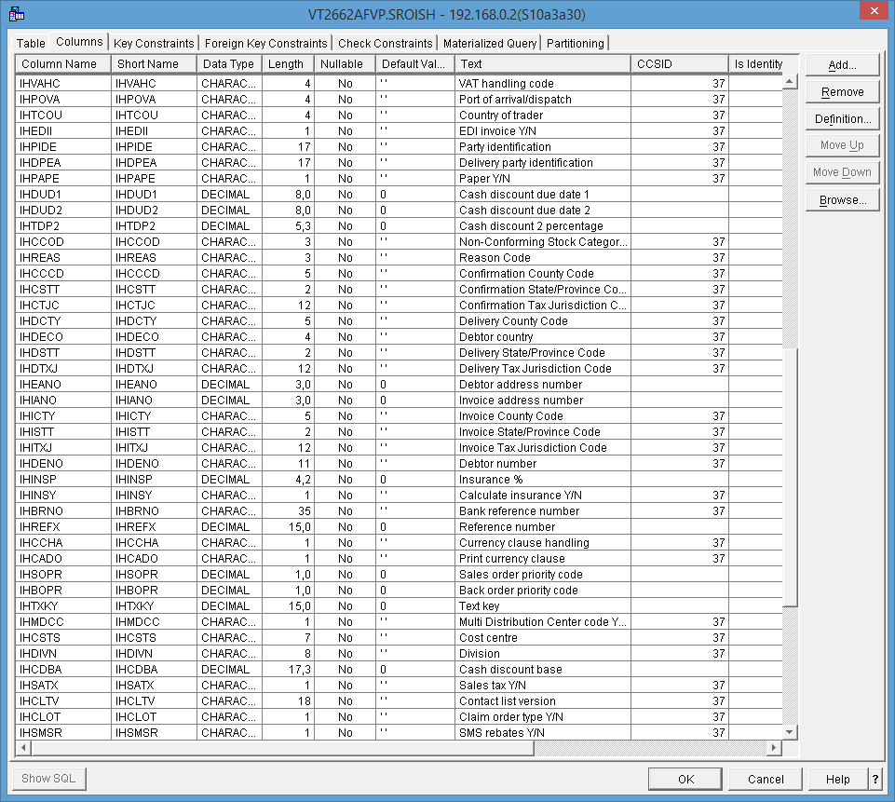

3 of 3

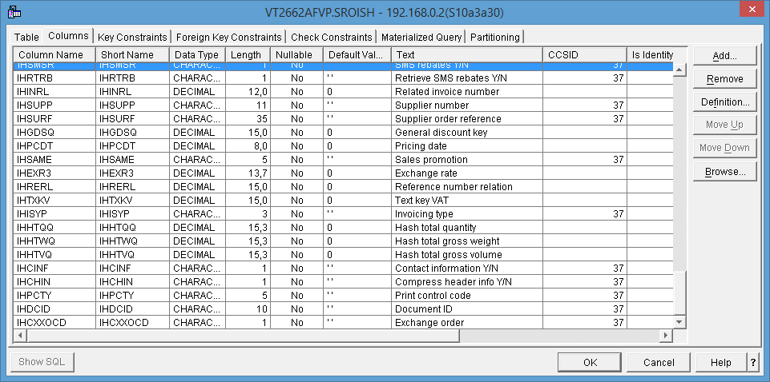

### A/R Transaction file

1 of 2

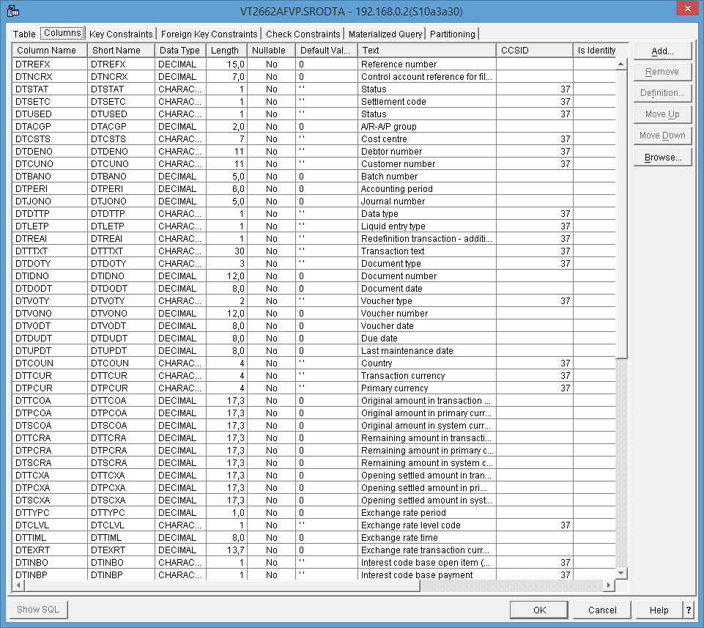

2 of 2

